PASAJE YTHACA - ALBUQUERQUE

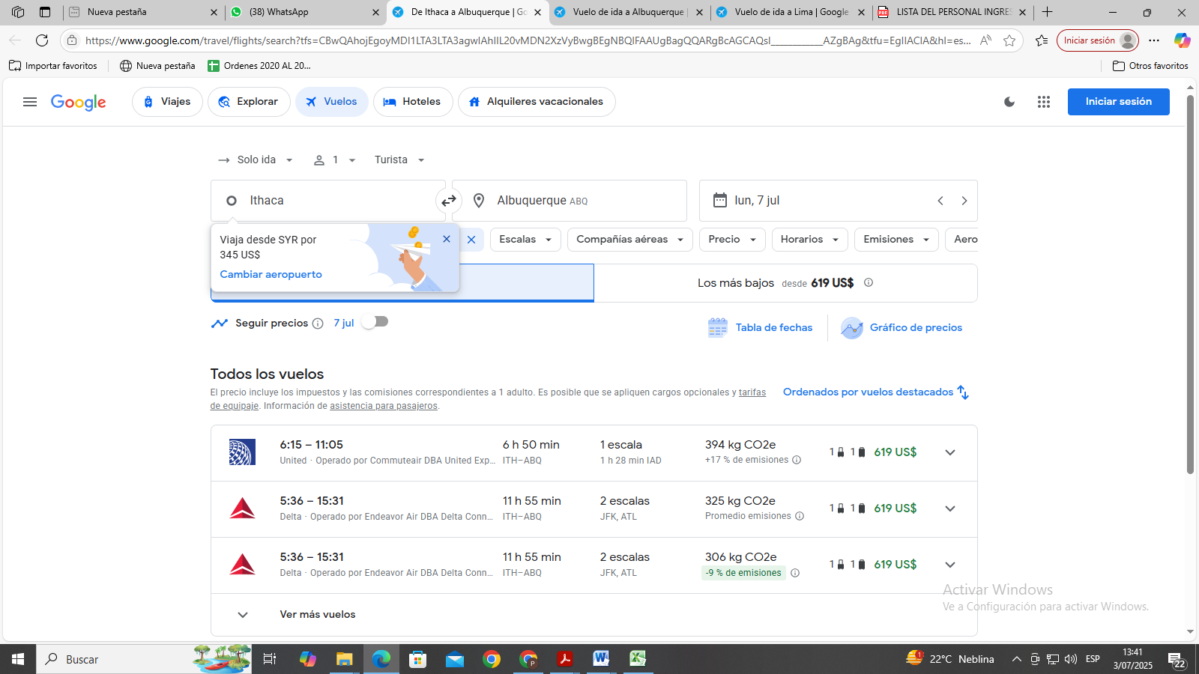

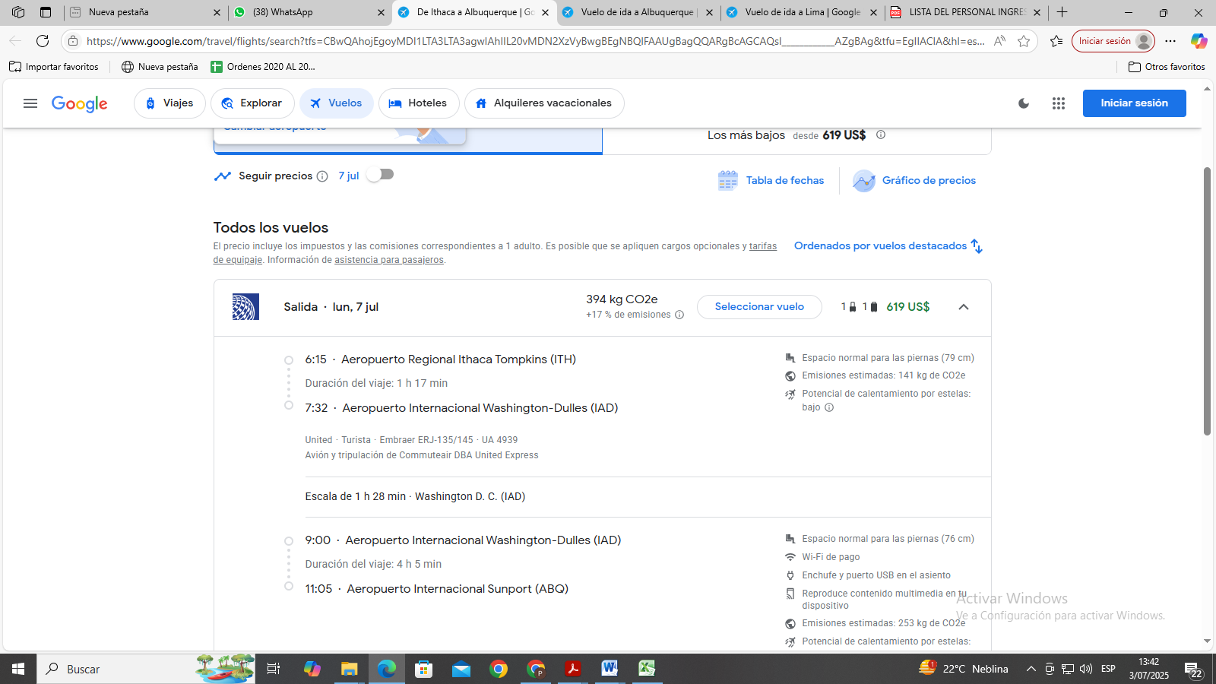

Link

https://www.google.com/travel/flights/search?tfs=CBwQAhojEgoyMDI1LTA3LTA3agwIAhIIL20vMDN2XzVyBwgBEgNBQlFAAUgBagQQARgBcAGCAQsI____________AZgBAg&tfu=EgIIACIA&hl=es&gl=PE&curr=USD